Day89-91 - Task46 - Kubernetes(Part-10)

1. Setup eks cluster using eksctl
Step 1: Prerequisites
- AWS account
- AWS CLI
- kubectl
- eksctl
- IAM permissions to create EKS-related resources
We can do the setup from our local Windows PC using PowerShell or Git Bash.
Step 2: Check the tools
Run:
aws –version
kubectl version –client

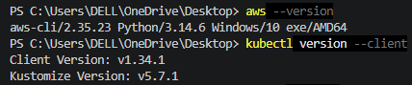

When executed eksctl version it was not found, so install it.
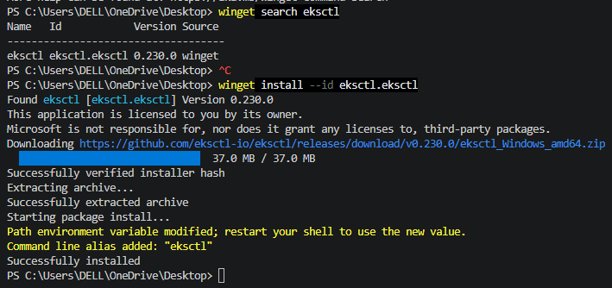
All three commands should return version information.
Step 3: Configure AWS CLI
Run:
aws configure
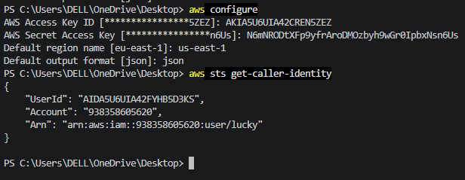
Step 4: Create the EKS cluster
Using the below command create cluster

eksctl create cluster \
--name my-eks-cluster \
--region us-east-1 \
--nodegroup-name worker-nodes \
--node-type t3.medium \
--nodes 2 \
--nodes-min 2 \
--nodes-max 3 \
--managed
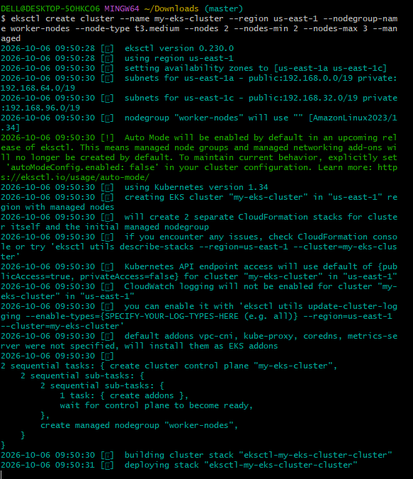
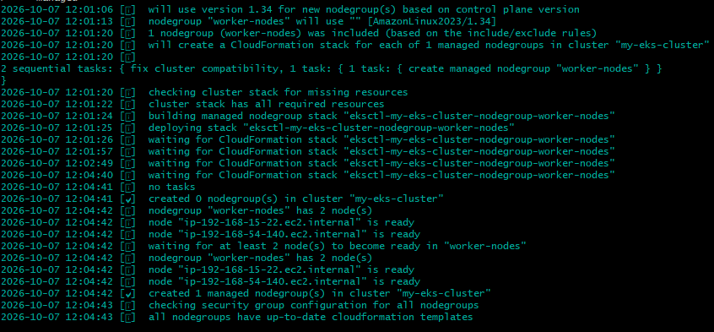

Above command creates:
- EKS cluster → my-eks-cluster
- Region → us-east-1
- Managed node group → worker-nodes
- EC2 instance type → t3.medium
- Initial worker nodes → 2
- Minimum nodes → 2
- Maximum nodes → 3
EKS Cluster:
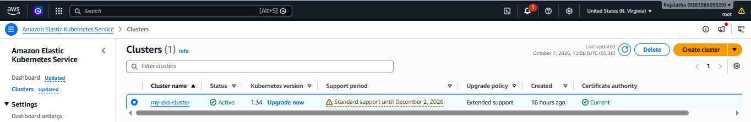
Worker nodes:
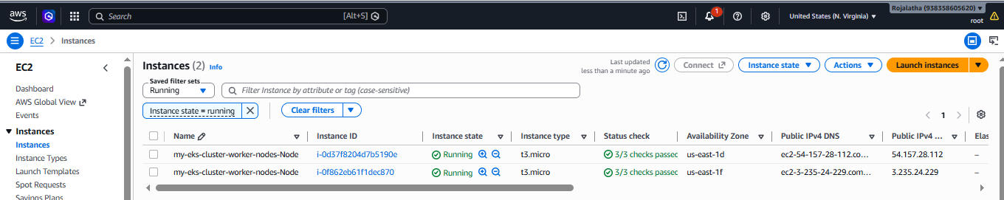

Note: EKS creation can take around 15–20 minutes and creates AWS resources that incur charges.
Step 5 — Wait for completion
Check the region of the cluster:
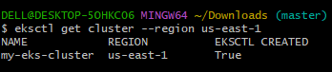

Step 6— Check worker nodes
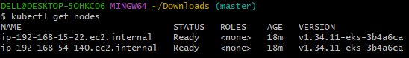
Step 7 — Check all EKS resources
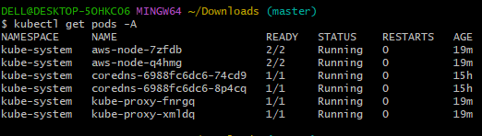
2. Setup eks cluster using console
Step 1: Open Amazon EKS
- Log in to the AWS Console.
- Search for EKS.
- Select Elastic Kubernetes Service.
- Make sure the region is:
US East (N. Virginia) — us-east-1
Go to:
EKS → Clusters → Add cluster → Create
Select:
Creation type:
Amazon EKS
Choose cluster configuration give cluster name and kubernetes version.
Configuring Cluster IAM Role and Node IAM role.

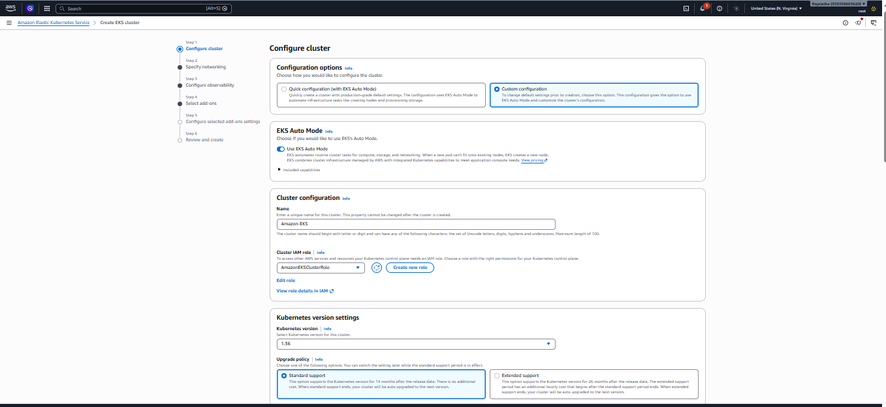
Select VPC and subnets:
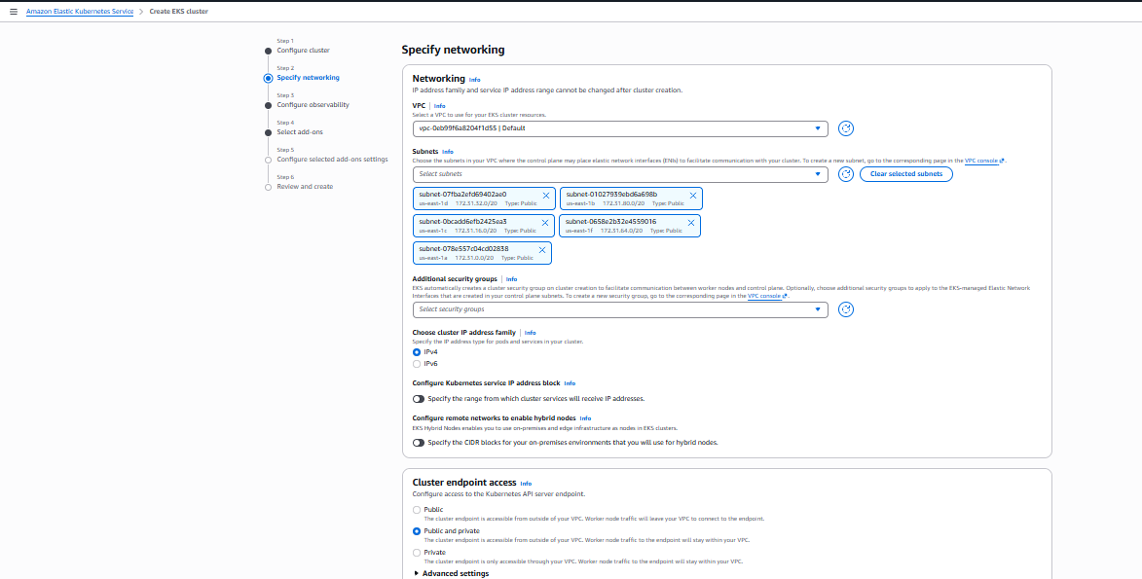
Keep security setting and logging as it is. Donot change them
Click on create cluster.
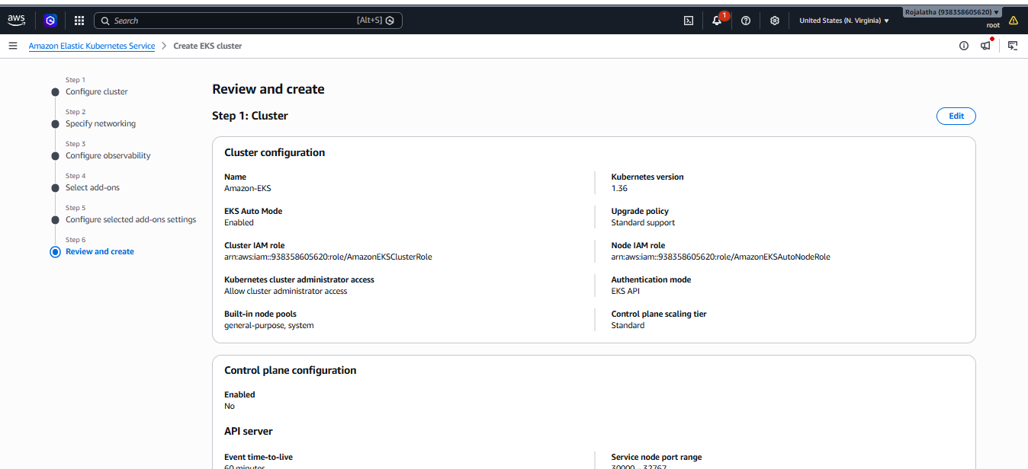
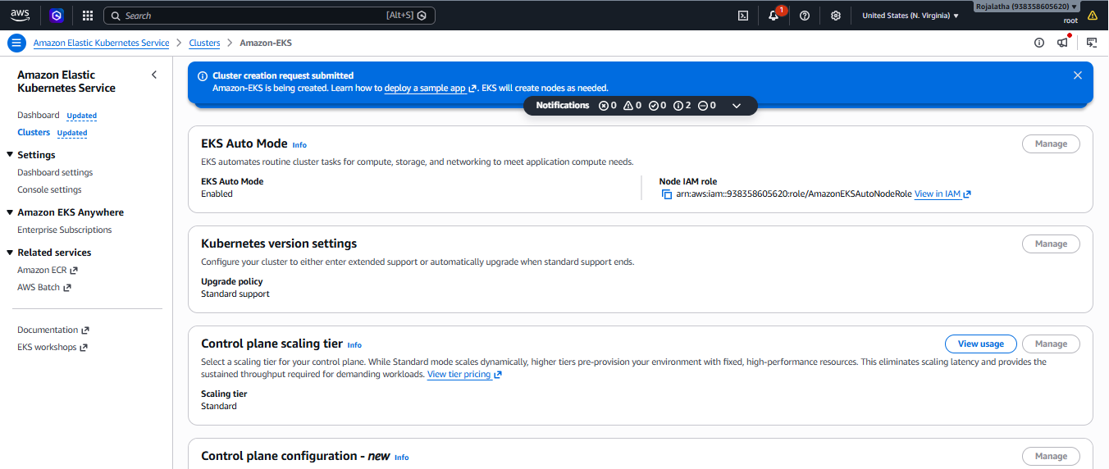
Cluster is created and is in creating status:
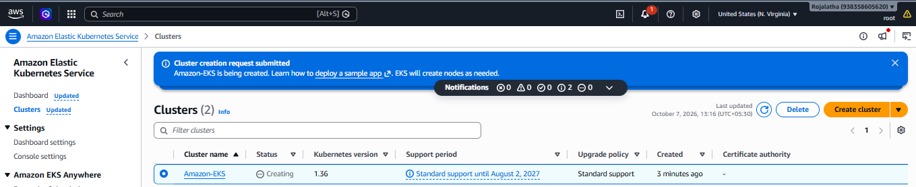

Cluster is now showing Active status:

3. Setup HPA

Step 1: Check your EKS nodes
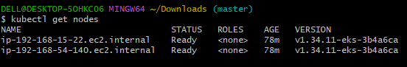

Step 2.Check Metrics Server
HPA needs CPU/memory metrics.
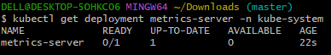
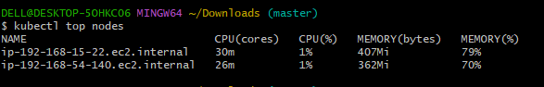
If kubectl top nodes shows CPU and memory, then metric server is working.
Step 3. Create a test application
Once metrics are working, create an NGINX deployment:
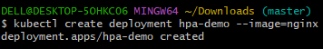
Check it:
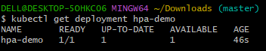
Step 4. Give the deployment CPU resources
HPA needs resource requests to calculate CPU utilization.
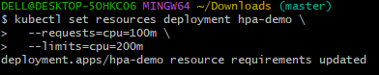
Check:
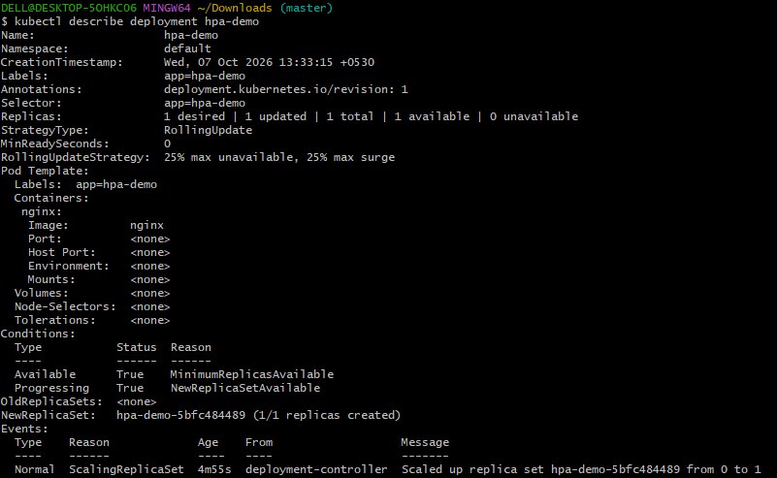
Step 5. Create the HPA
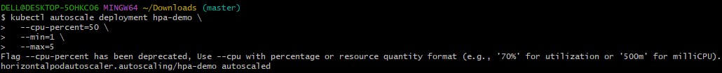
This means:
Minimum pods = 1
Maximum pods = 5
Target CPU = 50%

Check:
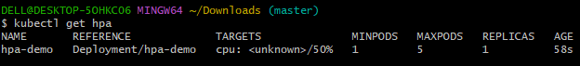
Step 6. Verify HPA details
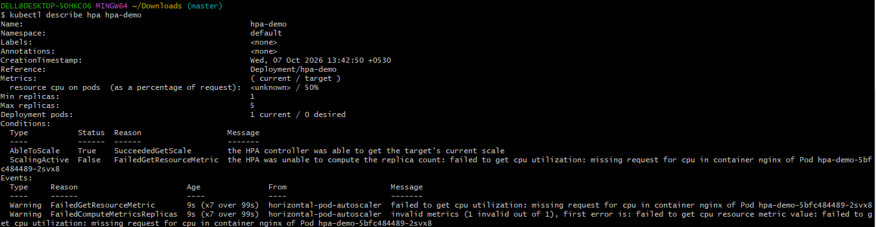
Step 7. Test autoscaling
We can generate CPU load later and watch the pods increase:
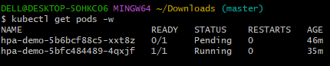
Describe the pod hpa-demo-5b6bcf88c5-xxt8z which is not running check for events:
That message explains the problem exactly:
0/2 nodes are available: 2 Too many pods
2 EKS worker nodes have reached their pod capacity. This is not an HPA error.
Because we are using t3.micro nodes, they have limited resources/pod capacity.
Go to:
AWS Console → EKS → Clusters → your EKS cluster → Compute
Select your node group: worker-nodes
Choose: Edit
Find Scaling configuration.
Set:
Desired size: 3
Minimum size: 2
Maximum size: 3
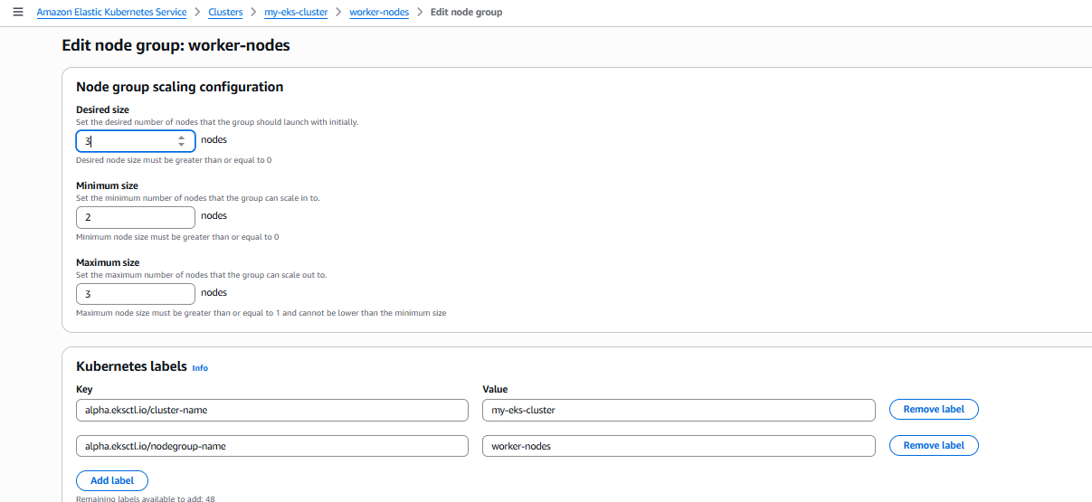
Then click:
Save changes
Wait for the node
Now run:
kubectl get nodes -w
We see three nodes are created and are ready.
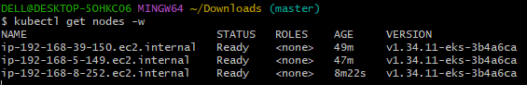
3. Setup cluster autoscale
Step 1. Check your cluster and node group
Check the version of kubernetes Cluster
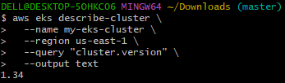

Check the scaling settings of an EKS managed node group
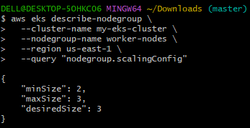
Step 2. Check your current nodes
We should see worker nodes Ready.
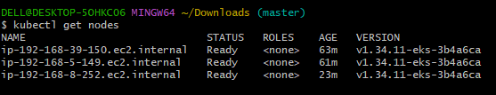
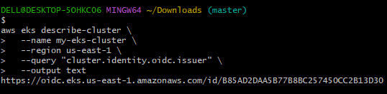
As it returns something like:
https://oidc.eks.us-east-1.amazonaws.com/id/XXXXXXXX then we can use IRSA.
Step 4. Also check your node group
Finds the Auto Scaling Group (ASG) associated with your EKS managed node group
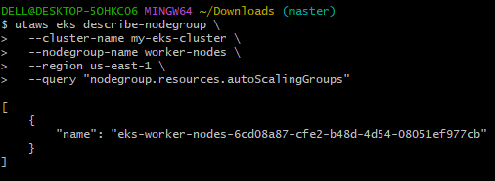
The name is the AWS Auto Scaling Group that EKS created for worker-nodes.
Step 5. Create an IAM policy for Cluster Autoscaler
We need to give the autoscaler permission to change the EKS node group's desired size.
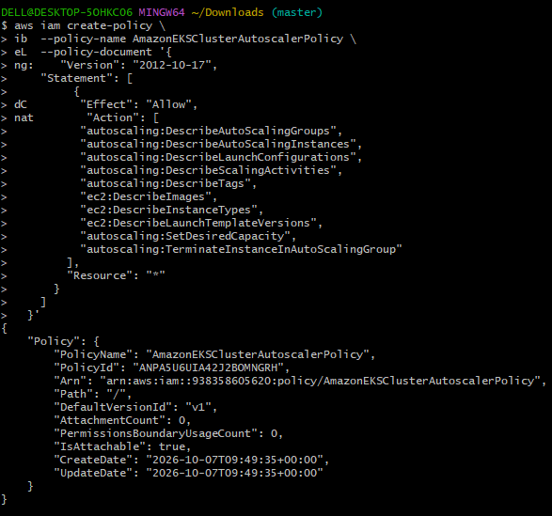
Step 6. Get your AWS account ID
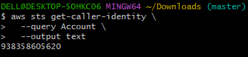
Step 7. Create an IAM trust policy
Create a file:
Vi trust-policy.sh and add policy
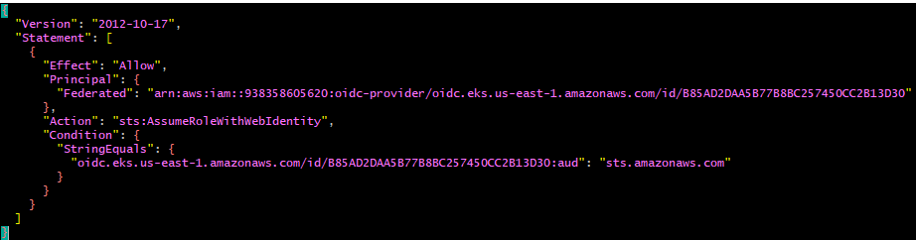
Save and exit.
Step 8. Create the IAM role
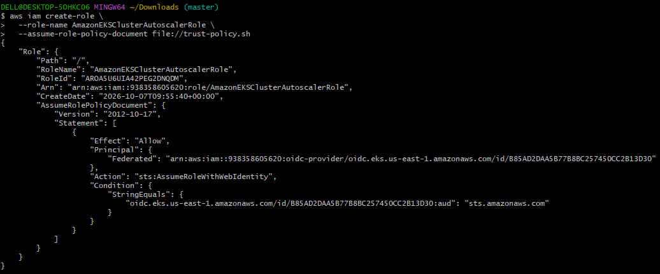

Step 9. Attach the policy

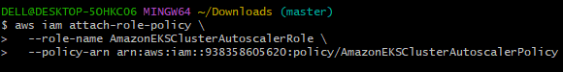

Step 10. Get the role ARN
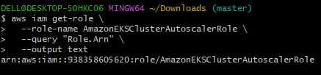
Step 11. Install Cluster Autoscaler
Now create the service account and deployment
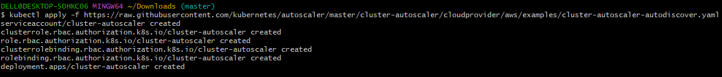
Then check the deployment
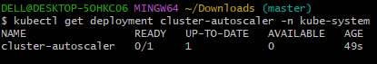
Step 12. Configure it for your cluster
Edit the deployment:
It opens notepad so edit the following part in spec:
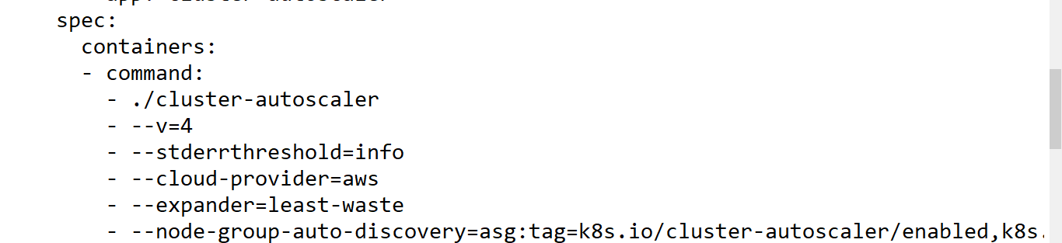
Also add the IAM role annotation to the ServiceAccount:
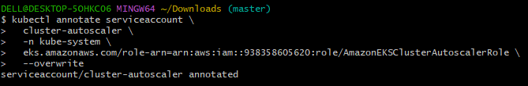
Then restart:
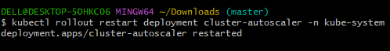
Step 13. Verify
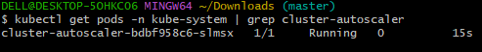
5. Setup cronjob and job
Step 1 — Create a Job
Create:
hello-job.yaml and add
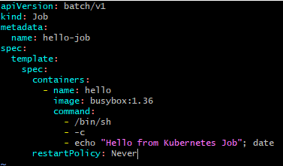
Step 2: Apply it:
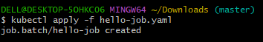
Step 3: Check the Job
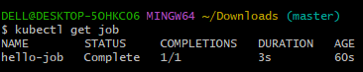
Then get the list of pods:
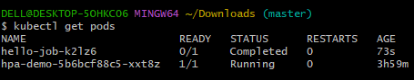
Check the logs/output produced by the hello-job Kubernetes Job.
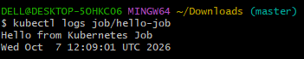
6. Create secret and inject inside pod
Step 1 — Create a Secret
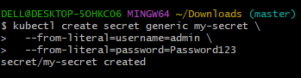
Check it:
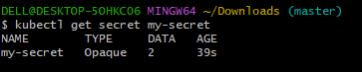
Step 2 — Create a Pod using the Secret
Create the YAML file:
vi secret-pod.yaml and add
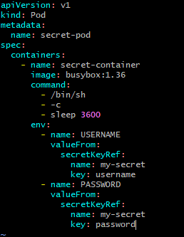
Save and exit.
Step 3 — Create the Pod
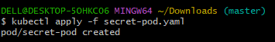
Check:
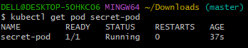
Step 4 — Verify the Secret inside the Pod
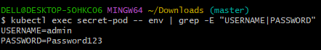
7. Check different add-ons available on eks.
Step 1 — List the EKS add-ons installed on your cluster
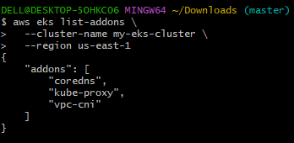
Step 2 — Get detailed information
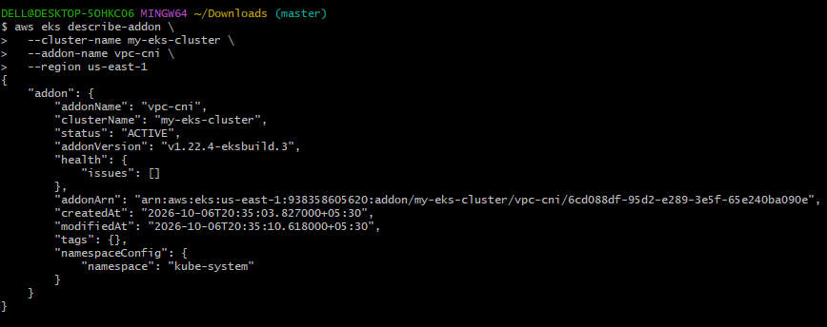
This shows information such as:
- Add-on name
- Version
- Status
- Health
- Configuration
Step 3 — Check add-ons from Kubernetes
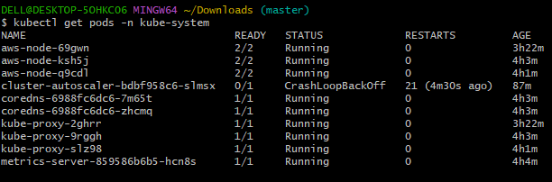
You'll see components such as:
aws-node
coredns
kube-proxy
metrics-server
cluster-autoscaler

8. Upgrade eks cluster
Step 1 — Get available versions correctly
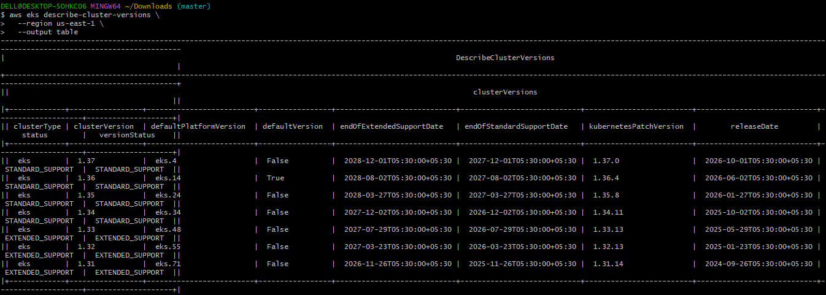
Step 2 — Upgrade the EKS control plane
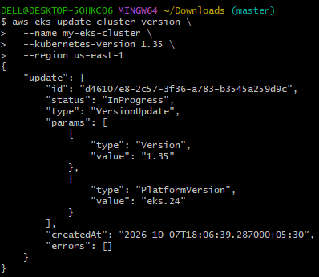
Step 3 — Monitor the upgrade
Status for upgrade is In-Progress:

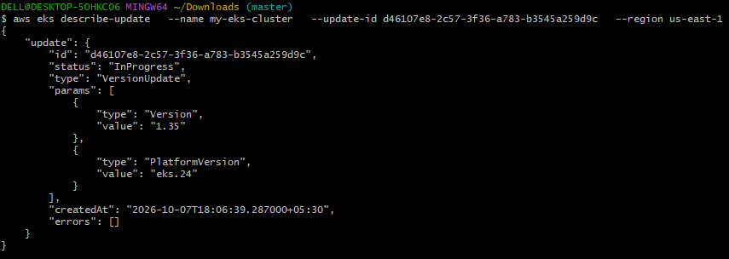
Keep checking until it shows: 1.35 and status successful as below
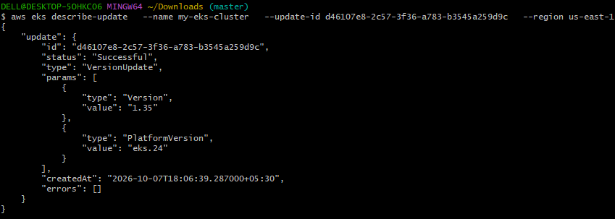
Step 4 — Upgrade the managed node group
Once the control plane is 1.35, upgrade your node group:
Status is In-progress
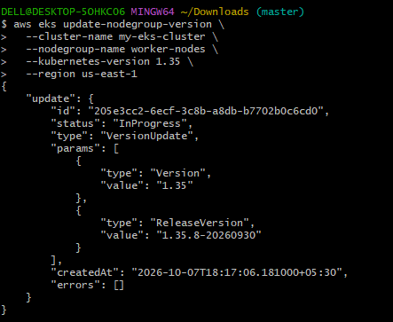
It should show status as successful and version 1.35
Node group version is updating:
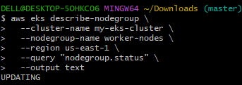
Step 4 — Check node group version
After the node-group upgrade finishes
Check the nodes which shows v1.35
